Project Design Phase – User Flow / User Journey
For DarshanEase, create this document:
Date:
Team ID: __________
Project Name: DarshanEase
User Flow
Step 1: User opens DarshanEase website.
⬇️
Step 2: User views temple details.
⬇️
Step 3: User checks available darshan slots.
⬇️
Step 4: User selects preferred date and time slot.
⬇️
Step 5: User enters booking details.
⬇️
Step 6: Booking is confirmed and stored in the database.
⬇️
Step 7: User can view booking details.
Admin Flow:
Admin Login
⬇️
View Bookings
⬇️
Manage Devotee Details
⬇️
Update Darshan Informatio
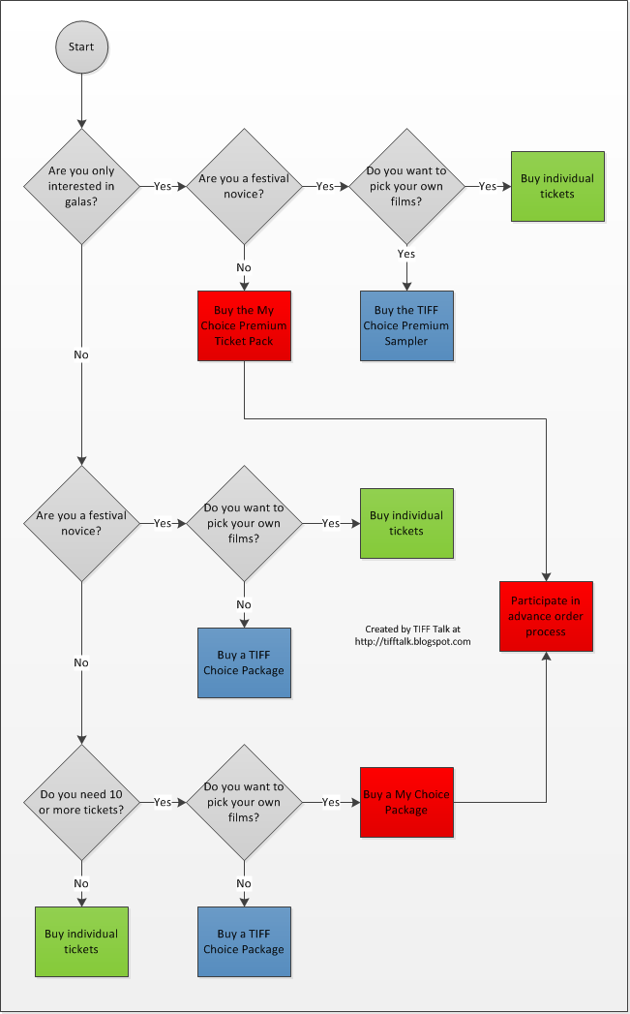
This Photo by Unknown Author is licensed under CC BY

